Lambeth Palace

Chapel

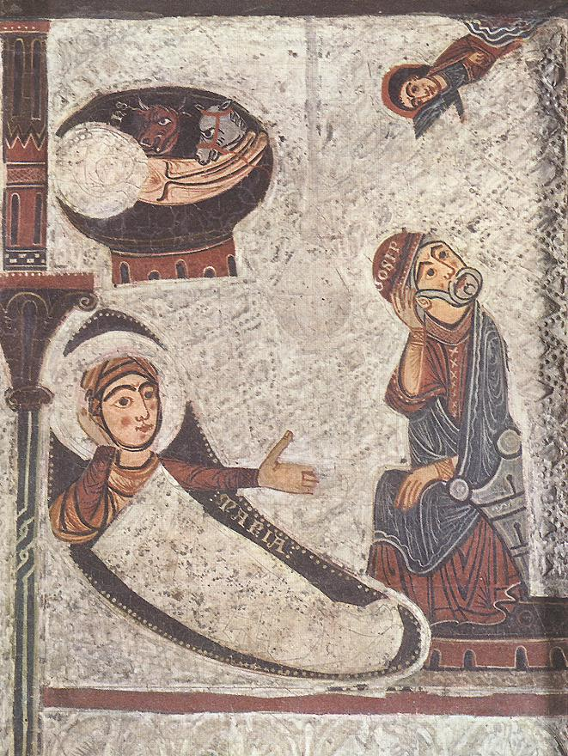

BBC Radio 4

Christmas Day Worship from Lambeth Palace

Congregational Carol

- Joy to the world, the Lord is come!
Let earth receive her King;
Let every heart prepare him room,
And heaven and nature sing,
And heaven and nature sing,
And heaven, and heaven and nature sing.

- Joy to the world, the Saviour reigns!
Let all their songs employ;
While fields and floods, rocks, hills and plains
Repeat the sounding joy,
Repeat the sounding joy,
Repeat, repeat the sounding joy.

- He rules the world with truth and grace,
And makes the nations prove
The glories of his righteousness
And wonders of his love,
And wonders of his love,
And wonders, wonders of his love.
Isaac Watts (1674–1748)

Opening responses

Welcome all wonders in one sight!
Eternity shut in a span.
Summer in winter, day in night,
heaven in earth and God in man.
Great little one whose all-embracing birth
brings earth to heaven,
stoops heaven to earth.

Grace, mercy and peace, from God our Father and our Saviour Jesus Christ be always with you.
All And also with you.

Lighting of the Christmas candle

God our Father,
today the Saviour is born,
and those who live in darkness are seeing a great light.
Help us, who greet the birth of Christ with joy,
to live in the light of your Son
and to share the good news of your love.
We ask this through Jesus Christ,
the light who has come into the world.
All Amen.

Feature – Community of St Anselm
Members of the Community of St Anselm speak about their experiences of Christmas and what the birth of Jesus means to them.

Congregational carol

- In the bleak mid-winter,
Frosty wind made moan,
Earth stood hard as iron,
Water like a stone;
Snow had fallen, snow on snow,
Snow on snow,
In the bleak mid-winter,
Long ago.

- Our God, heaven cannot hold Him,
Nor earth sustain;
Heaven and earth shall flee away
When He comes to reign:
In the bleak mid-winter
A stable-place sufficed
The Lord God Almighty,
Jesus Christ.

- Angels and archangels
May have gathered there,
Cherubim and seraphim
Throngèd the air;
But only His mother,
In her maiden bliss,
Worshipped the Beloved
With a kiss.

- What can I give Him,
Poor as I am?
If I were a shepherd,
I would bring a lamb;
If I were a wise man,
I would do my part;
Yet what I can I give Him-
Give my heart.
Christina G Rossetti (1830-1894)

Reading
Luke 2: 1-7
Read by Rosemary Nuamah Williams

The Birth of Jesus
In those days a decree went out from Emperor Augustus that all the world should be registered. This was the first registration and was taken while Quirinius was governor of Syria. All went to their own towns to be registered. Joseph also went from the town of Nazareth in Galilee to Judea, to the city of David called Bethlehem, because he was descended from the house and family of David. He went to be registered with Mary, to whom he was engaged and who was expecting a child. While they were there, the time came for her to deliver her child. And she gave birth to her firstborn son and wrapped him in bands of cloth, and laid him in a manger, because there was no place for them in the inn.

Music
O little town of Bethlehem - Will Todd
St Martin’s Voices

Reflection
Archbishop Justin

Congregational carol

- See amid the winter's snow,
born for us on earth below,
see the tender Lamb appears,
promised from eternal years.
Hail, thou ever-blessèd morn!
Hail, redemption's happy dawn!
Sing through all Jerusalem,
Christ is born in Bethlehem!

- Lo, within a manger lies
he who built the starry skies,
he who, throned in height sublime,
sits amid the cherubim.
Chorus

- Sacred Infant, all divine,
what a tender love was thine,
thus to come from highest bliss
down to such a world as this!
Chorus

- Teach, O teach us, holy child,
by thy face so meek and mild,
teach us to resemble thee
in thy sweet humility.
Chorus

Edward Caswall (1814-1878)

Reading
Luke 2: 8-18
Read by Louise Donovan

The Shepherds and the Angels
In that region there were shepherds living in the fields, keeping watch over their flock by night. Then an angel of the Lord stood before them, and the glory of the Lord shone around them, and they were terrified. But the angel said to them, “Do not be afraid; for see - I am bringing you good news of great joy for all the people: to you is born this day in the city of David a Saviour, who is the Messiah, the Lord. This will be a sign for you: you will find a child wrapped in bands of cloth and lying in a manger.” And suddenly there was with the angel a multitude of the heavenly host, praising God and saying,
“Glory to God in the highest heaven,
and on earth peace among those whom he favors!”
When the angels had left them and gone into heaven, the shepherds said to one another, “Let us go now to Bethlehem and see this thing that has taken place, which the Lord has made known to us.” So they went with haste and found Mary and Joseph, and the child lying in the manger. When they saw this, they made known what had been told them about this child; and all who heard it were amazed at what the shepherds told them.

Reflection
Archbishop Justin

Music
My Lord has come – Will Todd
St Martin’s Voices

Reading
John 1. 1-5, 14
Read by Adam Hobson

The Word Became Flesh
In the beginning was the Word, and the Word was with God, and the Word was God. He was in the beginning with God. All things came into being through him, and without him not one thing came into being. What has come into being in him was life, and the life was the light of all people. The light shines in the darkness, and the darkness did not overcome it.
And the Word became flesh and lived among us, and we have seen his glory, the glory as of a father’s only son, full of grace and truth

Reflection
Archbishop Justin

Music
A Miracle (from ‘The Manchester Carols’) – Sasha Johnson Manning
St Martin’s Voices

Prayers
Led by members of St Anselm Community

The Lord’s Prayer
As our saviour taught us so we pray:
All Our Father in heaven,
hallowed be your name,
your kingdom come, your will be done,
on earth as in heaven.
Give us today our daily bread.
Forgive us our sins
as we forgive those who sin against us.
Lead us not into temptation
but deliver us from evil.
For the kingdom, the power,
and the glory are yours
now and for ever.
Amen.

Music
Follow that Star
Peter Gritton

Blessing by Archbishop Justin

May the Father, who has loved the eternal Son
from before the foundation of the world,
shed that love upon you his children.
All Amen.

May Christ, who by his incarnation
gathered into one things earthly and heavenly,
ﬁll you with joy and peace.
All Amen.

May the Holy Spirit, by whose overshadowing
Mary became the God-bearer,
give you grace to carry the good news of Christ.
All Amen.
And the blessing of God almighty,
the Father, the Son, and the Holy Spirit,
be among you and remain with you always.
All Amen.

Dismissal

Go in peace. Proclaim the Word made ﬂesh.
All Glory, thanks and praise to God.

Congregational carol

- Hark, the herald-angels sing
glory to the new-born King,
peace on earth, and mercy mild,
God and sinners reconciled.
Joyful, all ye nations, rise,
join the triumph of the skies;
with the angelic host proclaim,
'Christ is born in Bethlehem.'
Hark, the herald-angels sing
glory to the new-born King.

- Christ, by highest heaven adored,
Christ, the everlasting Lord,
late in time behold him come,
offspring of a Virgin's womb.
Veiled in flesh the Godhead see:
hail, the incarnate Deity,
pleased as man with man to dwell,
Jesus, our Emmanuel.
Hark, the herald-angels sing
glory to the new-born King.

- Hail, the heaven-born Prince of Peace:
hail, the Sun of Righteousness.
Light and life to all he brings,
risen with healing in his wings.
Mild he lays his glory by,
born that man no more may die,
born to raise the sons of earth,
born to give them second birth.
Hark, the herald-angels sing
glory to the new-born King.

Charles Wesley, (1707-1788), George Whitfield (1714-1770), Martin Madan

Organ Voluntary

